**CASSAVA LEAF DISEASES CLASSIFICATION - IDENTIFY THE TYPE OF DISEASES PRESENT ON A CASSAVA LEAF IMAGE**.

**1.0. INTRO AND LITERATURE REVIEW**

**1.0.1. Background and Significance of study:**

The world population has an estimate of 7.6 billion people as at 2019 and is projected to have reached the 10 billion mark by 2050. However, the available landmass remains the same despite the ever increasing human population. Only about 11.58%(17.25 million sq.km,6.666 million sq.km) of landmass is for agricultural use (central Intelligence Agency, 2016; United nations, department of Economic and Social Affairs, Population Division, 2017) with the human population consuming about 2940 kcal per capita per day of food(Vasileska, 2012)

Cassava or Tapioca(Manihot esculenta crantz) is an annual root crop that grows in tropical and sub tropical regions and is the most widely grown root crop that produces an edible tuber which is a third major source of carbohydrates after rice and maize for about 800 million people worldwide(FAD, 2013). It is usually bitter or sweet based on the amount of cyanide compounds found in it. The amount of cassava produced globally each year is about 203 million megatonnes( Alexandratos and Bruinsma, 2012). It is considered an economic crop as well as a key agro-industrial crop since it is primarily transformed into starch and dried cassava and further processed to the high value products such as modified starch, ethanol, monosodium glutamate, sweeteners etc

The farm phase in cassava supply chain is deemed the most critical part since a large number of farmers lack the appropriate knowledge and expertise for farm management. Other than cultivation methods, an epidemic of cassava diseases affects the cassava yield significantly as well as plant security. Due to cassava being propagated from the stems, it is vulnerable to be infected by many kinds of viruses. The epidemic diseases usually found in cassava includes cassava brown streak virus diseases(CBSD), cassava bacterial blight(CBB), cassava Green Mite(CGM), and cassava Mosaic Diseases(CMD).

The Researchers from FAO (Food and Agricultural Organization) stated that it is difficult for farmers to examine the diseases outbreak at early stages due to lack of availability of suitable detecting systems. A large number of farmers cannot detect whether cassava contains the diseases until fresh roots are harvested because the symptom only appears on the roots. However, a laboratory test from a plant expert is usually carried out to detect a viral disease in cassava leaves. This is usually costly and takes too much time leaving farmers with the incapability to deal with the problem quickly and accurately. With the help of data science, it may be possible to identify common diseases so they can be treated. Each cassava image will be classified into four disease categories and a fifth category indicating a healthy leaf. With this, farmers may be able to quickly identify diseased plants, potentially saving their crops before they inflict irreparable damage.

**1.0.2. State of Art on the Topic:**

This is a Kaggle competition problem which was hosted around Mid February 2021. The best solution had an accuracy of about 90% on the test data. However, there is still room for innovation and improvement of existing solutions.

**1.0.3. Related works:**

The prevalence of pests and diseases has greatly reduced the yield of cassava crops leading to low productivity. Although the total losses caused by the cassava mosaic Diseases are extremely difficult to estimate, it remains a major cause of yield loss. The losses depend on the variety and stage of infection which can usually be substantial. Yield losses of 25-95% are reported (Bisimwa and Walangululu, 2015). Some Researchers have carried out a number of studies on cassava diseases and other plant related diseases and among them are the agriculturists, Engineers, Life scientists and Biologists.

In Sue Han Lee et al 2017 presented a paper on how deep learning extracts and learns features for plant classification and used convolutional neural networks (CNN) and deconvolutional network (DN) approach to obtain results that show that different orders of venation are the best representative features and that multi level representation exists only in leaf data corresponding to species classes, which fits with the hierarchical botanical definitions of leaf characters. The work grants insights into the design of a new hybrid feature extraction models and improves the discriminative power of plant classification systems but focused more on the leaf feature extraction rather than the actual disease detection. Also, Konstantinos P. Feretinos 2018 in a paper titled deep learning models for plant disease detection and diagnosis worked at developing convolutional neural network models to perform plant diseases detection and diagnosis using simple leave images of healthy and diseased plants, through deep learning methodologies. Training of the model was performed with the use of an open database of 87,848 images, containing 25 different plants in a set of 58 distinct classes of plant and diseases combination including healthy plants. The work achieved the best performance of a very high success rate of 99.53% which was deemed significantly high resulting in the model to be a very useful advisory or early warning tool but the dataset used contained unverified images causing inaccuracy in selected cases and the focus was not on cassava and/or cassava diseases.

While in Amanda Ramcharan et al 2017 a work on deep learning for image based cassava diseases detection using a dataset of cassava diseases images was considered which was taken in a field in Tanzania. The Researchers applied transfer learning to train a deep convolutional neural network in order to identify three diseases and two types of pest damage. In their work the best trained model accuracies were 98% for brown leaf spot(BLS), 96% for red mite damage(RMD), 95% for green mite damage(GMD), 96% for cassava mosaic diseases(CMD), 98% for cassava brown streak disease(CBSD) and the best model achieved an overall accuracy of 93% for data not used in the training process. Although the work used deep learning approach to achieve the overall accuracy of 93% when compared to traditional machine learning approaches and also used transfer learning which offers a fast affordable and easily deployable strategy for digital plant diseases detection but the work fails to address the occurrence of cassava bacterial blight diseases.

There are also various interesting solutions on Kaggle. Many contributors showcased various interesting solutions to the cassava leaf diseases classification problem including use of ViTs(Vision Transformers). Upon investigation, some of the models that gave reasonable accuracies of above 80% include EfficientNet, ResNet, CropNet, ViT, DeiT(Data Efficient Image Transformers).

**1.0.4. Motivation of the Project:**

Cassava is the second largest carbohydrate in Africa. Despite the cassava crop being able to withstand harsh conditions, it is susceptible to viral infection which greatly affects produce and cuts profits for these individuals. Moreover, it is pertinent to find a cheap and flexible solution that aids in identifying the kind if viral diseases on these infected crops and treating these infected crops quickly and effectively

Being an African, a black and more specifically, a Nigerian, I feel a sense of responsibility to help solve one of Africa’s biggest causes of cassava food shortage, and low yield to small scale farmers and general consumers.

**1.0.5. Objective of the Project:**

The Objective of the project is to develop a deep learning model that on presentation of a visual image of the crop would correctly classify the crop as being healthy or infected with a particular disease with at least an accuracy of 85%.

**2.0. DESCRIPTION OF THE THEORY, DESIGN AND IMPLEMENTATION**

**2.0.1. Introduction:**

Deep learning systems have become important technique to address the agricultural problem of plant diseases. Deep learning is a part of machine learning that trains data by using network layers with multiple neurons and extracts higher levels of data features as a result of its deep layers. Convolutional Neural Networks (CNN) is a deep learning Algorithm that is effectively applicable to visual data. For this project, we will be using the transfer learning technique which usually comes in two stages: Feature Extraction and Classification. The EfficientNetB3 and VGG16 models produced the most accurate results and are demonstrated in this project.

**2.0.2. Model Development**

In this project, I carried out tests with deep learning models such as ResNet50, EfficientNetB3, EfficientNetB0 and VGG16. These are pre trained models for cassava leaf diseases detection. A pre trained model is a model already trained and learned by existing sources such as imagenet. However, to increase model performance we also apply a transfer learning to this pre trained algorithm so it could learn and train our data further. To implement the model we used keras. The programming language was python 3. First, we develop a baseline model, then going forward, as we actually begin to develop a more deep and complex model for cassava leaf disease classification, we plan on having our resized and preprocessed images be fed into a series of convolutional layers followed by a few dense, fully connected layers. A general diagram of what this might look like is included below for illustrative purposes, but, at this point, we have yet to establish what will be the optimal design for our layers and which characteristics and features will cause the model to yield the best results.

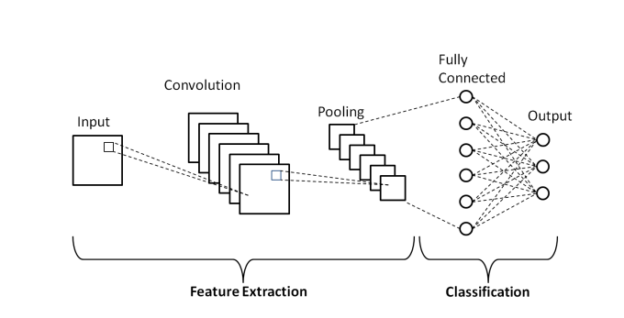

Fig 2.0: General CNN network

**2.0.3. Data set**

In this project, we will use a dataset of 21,367 labeled images collected during a regular survey in Uganda. Most images were crowd sourced from farmers taking photos of their gardens, and annotated by experts at the National Crops Resources Research Institute (NaCRRI) in collaboration with the AI lab at Makerere University, Kampala. This is in a format that most realistically represents what farmers would need to diagnose in real life. The dataset is available on Kaggle via <https://www.kaggle.com/c/cassava-leaf-disease-classification/data>. Some examples of the images are shown below

1. CBSD (c) CBB

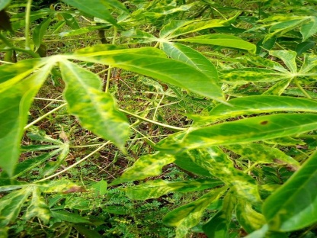 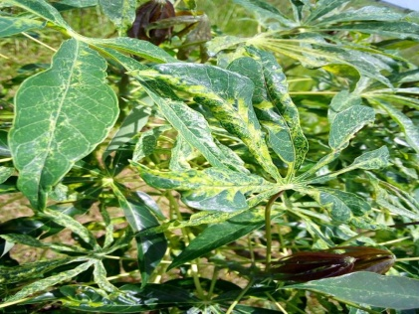

1. CMD (d) CGM

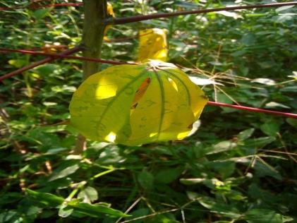 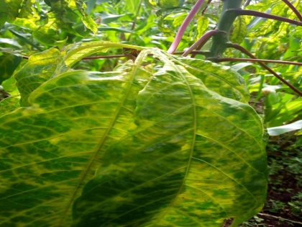

Fig. 2.0: sample cassava leave images in dataset

There are five labels in total, including four disease labels CBB, CBSD, CGM, and CMD as well as one healthy label. Our exploratory data analysis investigates the distribution of each class. From the graph below, we can see that the training labels are pretty imbalanced; with more than 12,000 CMD images while less than 2,000 CBB images. In other words, more than 60% of the training labels are CMD, while only around 5% of them are CBB. Hence, we are presented with an Imbalanced dataset.

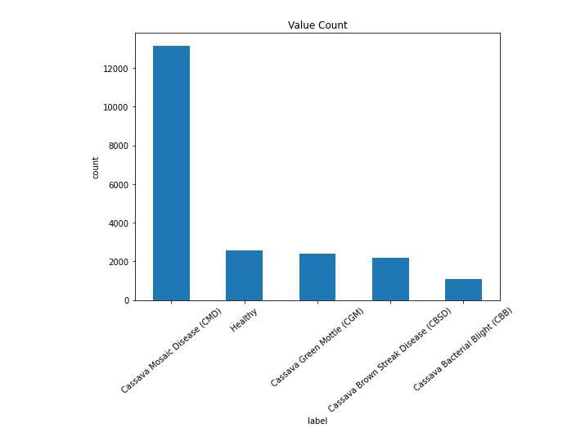

Fig 2.1 : Histogram showing imbalance in the dataset

**2.0.4. Image Resize**

The images downloaded from Kaggle are sized 800*600. In order to train CNN models more efficiently, we down sample the images and re-size them as 224*224 for VGG16 and 300*300 for EfficientNetB3. We also performed data augmentation and regularization on the training data.

**2.0.5. Baseline Model (VGG16)**

**2.0.5.1. Model Architecture**

The baseline model is built with transfer learning with VGG16 with imagenet retrained weight. The outputs of VGG16 are flattened before being fed into three fully connected layers with 512 nodes, 256 nodes and 128 nodes. We use softmax as activation function to avoid vanishing gradient. Dropout rates are all set to 0.5 to break model symmetry. The final dense layer, whose number of nodes equals the number of total classes, is added at the end. Considering that there are 5 possible output classes, softmax is used here as the activation function and categorical cross entropy is chosen as the loss function. Additionally, we use Adam as optimizer and accuracy as metrics.

We trained the CNN model with the Architecture shown in figure below by splitting the dataset into image training set and Image testing set. Please see code for more information

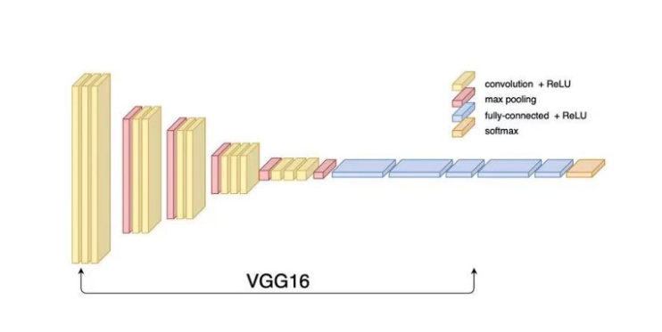

*Fig 2.1: VGG16 Architecture*

## 2.0.5.2. MODEL SUMMARY

## vgg2.PNG

## 2.0.5.2. Train History

From the training history plot below, we can see that the performance of our baseline model still needs to be improved. With more epochs involved, even though the training accuracy increases and the training loss decreases, the validation accuracy keeps almost the same and the validation loss increases significantly. In other words, our baseline model suffers from over fitting issue, which should be solved in our next phase by adjusting model hyper-parameters and applying early stopping strategy.

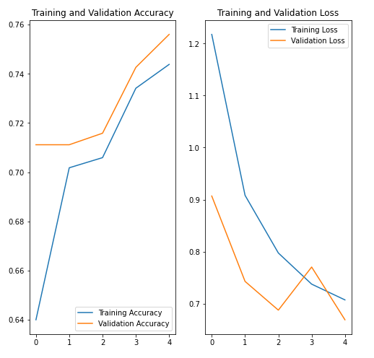

# Fig2.2. Train history plot

# 2.0.6. Next Steps

1. Advanced image preprocessing

Our current image preprocessing only resizes images from 800*600 to 224*224. However, using current image as input will lead to RAM crash if epoch is set large. Also, image issues like opacity and optical noise were not put into consideration. More work will be done on these areas to see how it can improve model performance

2. Handle dataset imbalance

Labels in the raw dataset are pretty imbalanced, which will potentially influence the performance of our model. We undersampled in thiscase but more methods of how to handle imbalance in data will be explored.

3. Adjust neural network architecture

The neural network we have now is relatively basic. Adjusting certain hyper-parameters and training strategies and combining other models besides VGG16 through transfer learning will be done in the next phase.

**2.0.7. Final Model: EfficientNetB3 Model**

These models are made too wide, deep or with very high resolution. The Efficient Net combines a new uniformly scaling method and AutoML to largely improve the training speed and accuracy.

EfficientNetB3 and EfficientNetB0 are tried in the training process. The difference between them is the depth of neural network. EfficientB3 contains more parameters to train with more complex model architecture, and EfficientNetB0 with less parameter would have advantages in computational time.

The final version of EfficientNet is using EfficientNetB3 with the imagenet retrained weight as the base model. By removing the top layers, we add a dropout layer after flatten the output, and then add several fully-connected layers with dropout layers, to prevent overfitting and make a more generalized model.

We set batch size to be 32. We apply regularization, and data augumentation techniques to improve the accuracy.

Also, we add some callbacks mechanisms to control the training processes. The early_stopping parameter would stop the model when there is no update on validation loss with 2 patience steps; the checkpoint could help the model to save current best model; and the reduce_lr could help the model to update the learning rate as settings.

**2.0.7.1. System Architecture:**

Basic block for all EfficientNet models(B0-B7) is shown below

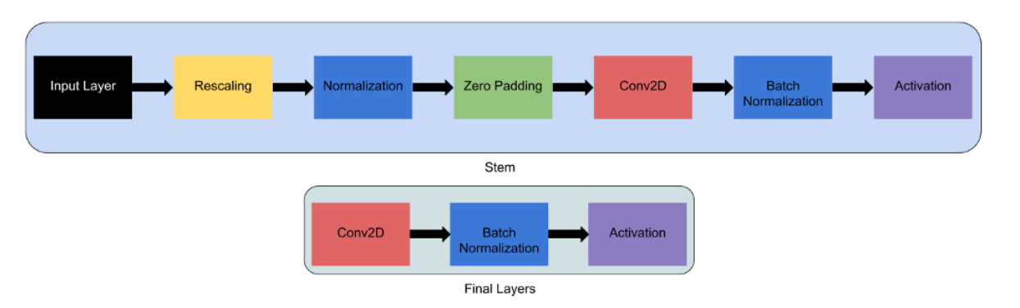

The Total number of layers in all EfficientNet Models (B0-B7) is made from these 5 modules shown below

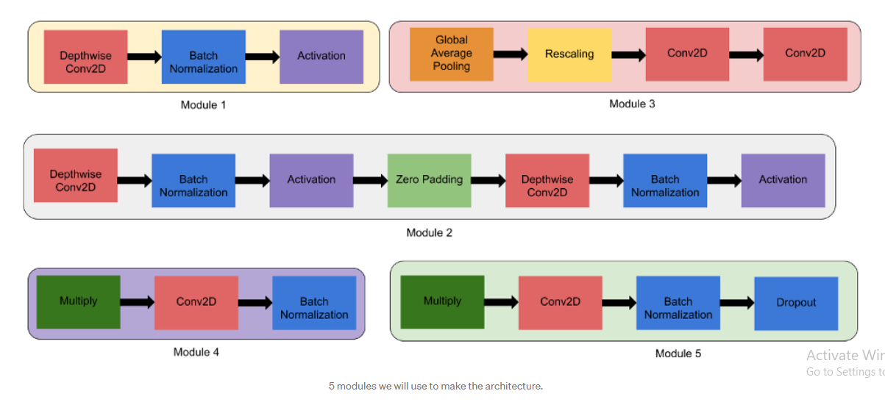

Architecture for EfficientNet B3 is shown below

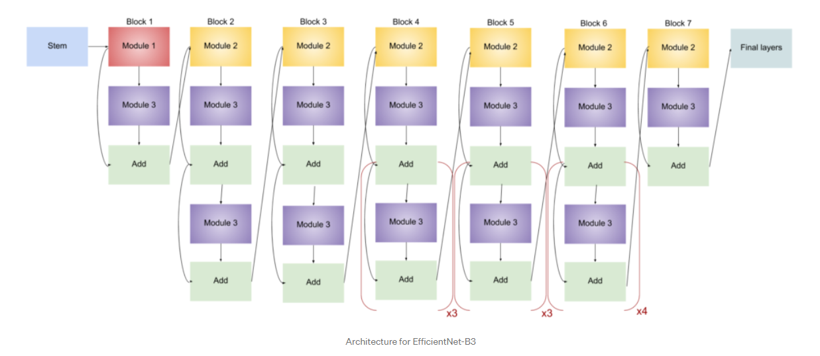

## 2.0.7.3. MODEL SUMMARY

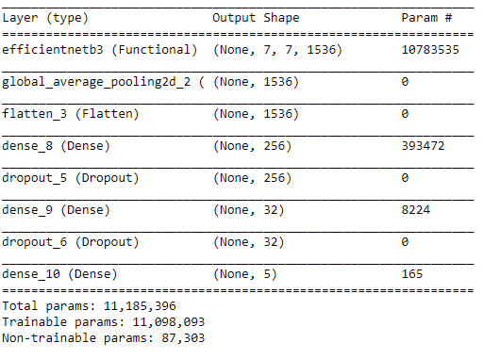

**2.0.7.3. Train History**

The final results are shown in the plots. The training and validation accuracy increases while the training and validation loss reduces

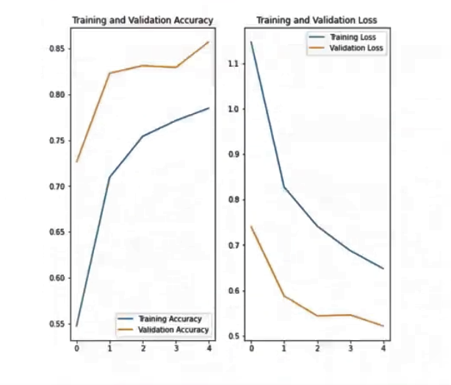

**2.0.8. CONCLUSION:**

This study addressed the difficulty of cassava diseases classification by analyzing cassava leaves. The Objective of the project was to develop a deep learning model that on presentation of a visual image of the crop would correctly classify the crop as being healthy or infected with a particular disease with at least an accuracy of 85%. We proposed novel method to classify cassava diseases classification. There were two models: VGG16 Model and EfficientNet B3 Models. Experimental results showed that the method provided an acceptable accuracy. So far, EfficientNetB3 has the highest accuracy of 0.85 while VGG16 and EfficientNetB0 accuracy is about 0.75. This may be because it has more deep layers that apply uniformity to increase in depth, length and resolution. Also, resampling the data with different ratios seemed to help improve accuracy along with regularization. In the future, I’m looking at building some part of the ResNet and EfficientNet and investigating ViT models to see whether it will further increase the performance to 95%.

**REFERENCES:**

Ozichi E et al 2019 Detection and Classification of Cassava Diseases Using Machine Learning

Ayu H R et al 2021 Deep Learning for Cassava Leaf Diseases J. Phys.: Conf. Ser. **1751** 012072

Vardan A. 2020 Complete Architectural Details of All EfficientNet Models retrieved from <https://towardsdatascience.com/complete-architectural-details-of-all-efficientnet-models-5fd5b736142>

Yangkin K. 2021 Cassava Leaf Diseases Classification – EDA and Baseline Model retrieved from <https://yangyin-ke.medium.com/cassava-leaf-disease-classification-eda-and-baseline-model-2d2c44703c83>

Huaqie N. 2021 Cassava Leaf Diseases Classification – Final Models retrieved from <https://huaqi-nie.medium.com/cassava-leaf-disease-classification-final-models-a0ef9254c318>

Makerere University AI Lab Cassava Leaf Diseases Classification retrieved from <https://www.kaggle.com/c/cassava-leaf-disease-classification/overview>

Griffin M. 2021 Cassava Leaf Diseases Classification Using Convolutional Neural Networks retrieved from <https://medium.com/mlearning-ai/cassava-leaf-disease-classification-using-convolutional-neural-networks-48fdc32cec1d>